 | Application Form  We Are Welders  Women’s Welding Program 2022 | PO Box 700, 2160 Fourth Line  Ohsweken ON N0A 1M0  519 445-0023 phone  519 445-4416 fax  Brantford Campus  411 Elgin Street  Brantford ON N3S 7P5  519-226-1245 phone  www.snpolytechnic.com
Instructions:
Complete all applicable sections of this application form (if a section is not applicable, leave it blank).
SNP will communicate with applicants via email, include an email address that you check frequently.

Program Selection
☐ We Are Welders Women’s Program (Fall 2022, includes an 8-week paid work placement)

PLEASE NOTE: Program dates may change due to government restrictions surrounding the Covid-19 pandemic. This program is a blend of in-person and online classes. Access to a computer and internet is required.
Contact Information:
Legal Surname | First Name | Email Address

To apply for We are Welder’s program, you must meet the following requirements:
☐ | Minimum 16 years old or older
☐ | Must be a resident and able to work in Ontario
☐ | Meet household income requirements set by the Government of Ontario  Household Income (what is your total before taxes): $  How many people reside in your household? Choose Number.  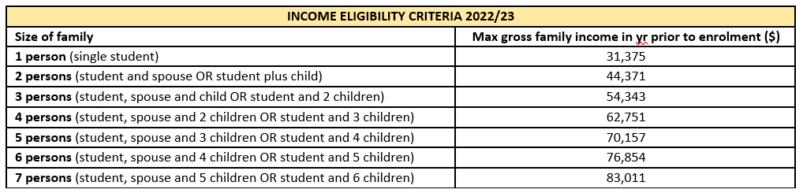
For students intending to apply to apprenticeship upon successful completion of the program, you must meet minimum entrance requirement for the trade, additional documentation includes:
☐ | OSSD or equivalent
☐ | An official copy of your high school transcript or equivalent
Submitting your application and transcript(s):
☐ High school transcript ☐ Transcript(s) from any other course/program ☐ Completed application form
Please email your package to admissions@snpolytechnic.com. You may also drop off a printed copy of your application at either campus location:
Ohsweken Campus  2160 Fourth Line  Ohsweken ON N0A 1M0  519 445-0023 phone  519 445-4416 fax | Brantford Campus  411 Elgin Street  Brantford ON N3S 7P5  519-226-1245 phone

Disclaimer re: eligibility and admission requirements
Women's Economic Security Programs are funded by the Government of Ontario. Information collected on this application will be used solely for the purposes of assessing eligibility and reporting as per the program guidelines set out by the Ministry and Office of Women’s Issues. Completion of this application does not guarantee acceptance into this program. Once your application has been received it will be reviewed for completeness and assessed against the eligibility criteria. All applications will be acknowledged, and you will be contacted if your application is incomplete or if there are further questions.

Section 1: Personal Information
Legal Surname | First Name | Middle Name(s)
Blue Flag # OR Street # | Street or Road Name |  | RR #
City | Province | Postal Code

 |  | Click to enter date
Home Phone # | Cell Phone # | Date of Birth
Choose an item.
Gender | Email Address

Status in Canada | ☐ Canadian Citizen ☐ Permanent Resident ☐ Other, please specify:
Complete this section if you wish to self-identify as a member of a designated group(s). Your response to this question is entirely voluntary and will not affect your eligibility.
☐ First Nations/Metis/Inuit ☐ Visible Minority ☐ Recent Immigrant (less than 5 years)
☐ Person with Disability ☐ LGBTQ+ ☐ Francophone
☐ Single Parent Family ☐ Temporarily Housed ☐ Survivor of Domestic Violence

Please select your current employment status
☐ Employed FT ☐ Employed PT ☐ Self-Employed ☐ Student
☐ Receiving OW ☐ Receiving ODSP ☐ Other: ___________________________________

Section 2: Academic History (Provide a certified copy of your last high school transcript as part of your application)
Please indicate your highest level of education completed:
☐ Grade 12 or equivalent |  | ☐ Grade 9 |  | ☐ Journeyperson
☐ Grade 11 |  | ☐ Grade 0 – 8 |  | ☐ Certificate or Diploma
☐ Grade 10 |  | ☐ Certificate of Apprenticeship |  | ☐ Degree
 | Name of high school attended:
 | What year did you complete/attend high school
 | Have you attended Six Nations Polytechnic in the past?
 | If yes, which program did you attend?

How did you hear about Six Nations Polytechnic and these programs?
☐ Newspaper | ☐ SNP Recruiter | ☐ Internet Search
☐ Mail | ☐ Other please specify: Click or tap here to enter text. | ☐ Social Media (i.e. Facebook, Instagram)

 | Consent Form  We are Welder Women’s Program | PO Box 700, 2160 Fourth Line  Ohsweken ON N0A 1M0  519 445-0023 phone  519 445-4416 fax  Brantford Campus  411 Elgin Street  Brantford ON N3S 7P5  519-226-1245 phone  www.snpolytechnic.com
Student Information
(click to enter text) | (click to enter text) |  | (click to enter text)
Legal Surname | First Name |  | Middle Name(s)
(click to enter text) |  | (click to enter text)
SNP Student Number (if applicable) |  | SNP E-mail Address (if applicable)

Consent to Request Information
I, (type legal name), provide my consent, as may be required by statute, to Six Nations Polytechnic to request copies of information from educational and employment and training institute(s); federal, provincial and Six Nations government offices/agencies. This consent allows Six Nations Polytechnic to verify information.

Consent to Release Information
I, (type legal name), provide my consent, as may be required by statute, to allow Six Nations Polytechnic to release information and provide copies of documentation to educational and employment and training institutes(s) and federal, provincial and Six Nations government offices/agencies. This consent allows Six Nations Polytechnic to provide information pertaining to my enrolment.

Declarations
Student

☐ I, (type legal name), have read and agree to the above. Date: (select)

